스마트폰프로그래밍

Assign #3

(과제명 : KeyEventTest 연습)

학번 : 2013305019

성명 : 김 지 민

제출일자 : 2017. 9. 28

본인은 타인이나 다른 매체를 도용하지 않았음을 확인합니다 <본인사인>

3.1

**package** com.example.kimji_min.assignment21;  
  
**import** android.support.v7.app.AppCompatActivity;  
**import** android.os.Bundle;  
**import** android.view.KeyEvent;  
**import** android.view.View;  
**import** android.widget.EditText;  
**import** android.widget.Toast;  
  
**public class** MainActivity **extends** AppCompatActivity {  
  
 @Override  
 **protected void** onCreate(Bundle savedInstanceState) {  
 **super**.onCreate(savedInstanceState);  
 setContentView(R.layout.***activity_main***);  
  
 **final** EditText editText = (EditText)findViewById(R.id.***editKey***);  
 editText.setOnKeyListener(**new** View.OnKeyListener() {  
  
 **public boolean** onKey(View view, **int** i, KeyEvent keyEvent) {  
 Toast.*makeText*(getApplicationContext(), editText.getText(), Toast.***LENGTH_SHORT***).show();  
 **return false**;  
 }  
 });  
 }  
}

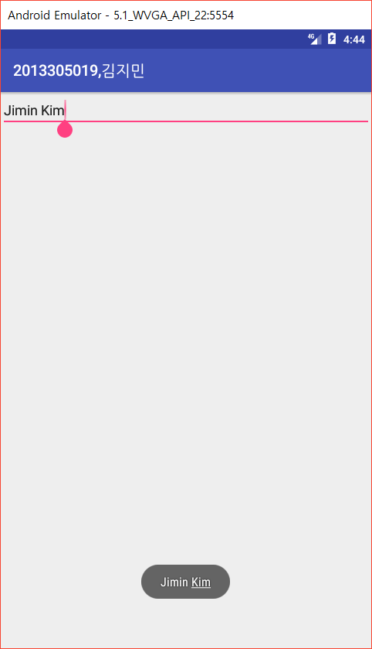

스마트폰프로그래밍

Assign #4

(과제명 : ChoiceTest 연습)

학번 : 2013305019

성명 : 김 지 민

제출일자 : 2017. 9. 28

본인은 타인이나 다른 매체를 도용하지 않았음을 확인합니다 <본인사인>

4.1

activity_main.xml

*<?***xml version="1.0" encoding="utf-8"***?>*<**LinearLayout xmlns:android="http://schemas.android.com/apk/res/android"  
 xmlns:app="http://schemas.android.com/apk/res-auto"  
 xmlns:tools="http://schemas.android.com/tools"  
 android:layout_width="match_parent"  
 android:layout_height="match_parent"  
 android:orientation="vertical"  
 tools:context="com.example.kimji_min.assignment22.MainActivity"**>  
  
 <**LinearLayout  
 android:id="@+id/master"  
 android:layout_width="match_parent"  
 android:layout_height="wrap_content"  
 android:layout_marginTop="10pt"  
 android:layout_marginLeft="10pt"**>  
 <**TextView  
 android:layout_width="wrap_content"  
 android:layout_height="wrap_content"  
 android:text="선택을 시작하겠습니까?"  
 app:layout_constraintTop_toTopOf="parent"** />  
 </**LinearLayout**>  
  
 <**LinearLayout  
 android:id="@+id/check_layout"  
 android:layout_width="match_parent"  
 android:layout_height="wrap_content"  
 android:orientation="vertical"  
 android:layout_marginTop="3pt"  
 android:layout_marginLeft="10pt"**>  
 <**CheckBox  
 android:id="@+id/checkbox_start"  
 android:layout_width="wrap_content"  
 android:layout_height="wrap_content"  
 android:text="시작함"  
 android:onClick="onCheckboxClicked"**/>  
 </**LinearLayout**>  
  
 <**LinearLayout  
 android:id="@+id/slave"  
 android:visibility="invisible"  
 android:layout_width="match_parent"  
 android:layout_height="wrap_content"  
 android:orientation="vertical"  
 android:layout_marginTop="3pt"  
 android:layout_marginLeft="10pt"**>  
 <**TextView  
 android:layout_width="wrap_content"  
 android:layout_height="wrap_content"  
 android:text="좋아하는 애완동물은?"  
 app:layout_constraintTop_toTopOf="parent"** />  
 <**RadioGroup  
 android:layout_width="match_parent"  
 android:layout_height="wrap_content"  
 android:orientation="vertical"  
 android:layout_marginTop="3pt"**>  
 <**RadioButton  
 android:id="@+id/dog"  
 android:layout_width="wrap_content"  
 android:layout_height="wrap_content"  
 android:onClick="onRadioButtonClicked"  
 android:text="강아지"**/>  
 <**RadioButton  
 android:id="@+id/cat"  
 android:layout_width="wrap_content"  
 android:layout_height="wrap_content"  
 android:onClick="onRadioButtonClicked"  
 android:text="고양이"**/>  
 <**RadioButton  
 android:id="@+id/duck"  
 android:layout_width="wrap_content"  
 android:layout_height="wrap_content"  
 android:onClick="onRadioButtonClicked"  
 android:text="오리"**/>  
 <**Button  
 android:id="@+id/button"  
 android:layout_width="wrap_content"  
 android:layout_height="wrap_content"  
 android:onClick="onButtonClicked"  
 android:text="선택 완료"**/>  
 </**RadioGroup**>  
 </**LinearLayout**>  
  
 <**ImageView  
 android:visibility="gone"  
 android:id="@+id/image_dog"  
 android:layout_width="match_parent"  
 android:layout_height="match_parent"  
 android:src="@drawable/dog"** />  
  
 <**ImageView  
 android:visibility="gone"  
 android:id="@+id/image_cat"  
 android:layout_width="match_parent"  
 android:layout_height="match_parent"  
 android:src="@drawable/cat"** />  
  
 <**ImageView  
 android:visibility="gone"  
 android:id="@+id/image_duck"  
 android:layout_width="match_parent"  
 android:layout_height="match_parent"  
 android:src="@drawable/duck"** />  
</**LinearLayout**>

MainActivity.java

**package** com.example.kimji_min.assignment22;  
  
**import** android.support.v7.app.AppCompatActivity;  
**import** android.os.Bundle;  
**import** android.view.View;  
**import** android.view.ViewGroup;  
**import** android.widget.CheckBox;  
**import** android.widget.ImageView;  
**import** android.widget.LinearLayout;  
**import** android.widget.RadioButton;  
**import** android.widget.TextView;  
  
**public class** MainActivity **extends** AppCompatActivity {  
 **int n**;  
 @Override  
 **protected void** onCreate(Bundle savedInstanceState) {  
 **super**.onCreate(savedInstanceState);  
 setContentView(R.layout.***activity_main***);  
 }  
  
 **public void** onRadioButtonClicked(View view){  
 **boolean** checked = ((RadioButton) view).isChecked();  
  
 **switch** (view.getId()) {  
 **case** R.id.***dog***:  
 **if** (checked) {  
 **n** = 1;  
 }  
 **break**;  
 **case** R.id.***cat***:  
 **if** (checked) {  
 **n** = 2;  
 }  
 **break**;  
 **case** R.id.***duck***:  
 **if** (checked) {  
 **n** = 3;  
 }  
 **break**;  
 }  
 }  
  
 **public void** onButtonClicked(View view){  
 ImageView imgv1 = (ImageView)findViewById(R.id.***image_dog***);  
 ImageView imgv2 = (ImageView)findViewById(R.id.***image_cat***);  
 ImageView imgv3 = (ImageView)findViewById(R.id.***image_duck***);  
  
 **if**(**n** == 1) {  
 imgv1.setVisibility(View.***VISIBLE***);  
 imgv2.setVisibility(View.***GONE***);  
 imgv3.setVisibility(View.***GONE***);  
 }  
 **else if**(**n** == 2){  
 imgv2.setVisibility(View.***VISIBLE***);  
 imgv1.setVisibility(View.***GONE***);  
 imgv3.setVisibility(View.***GONE***);  
 }  
 **else if**(**n** == 3){  
 imgv3.setVisibility(View.***VISIBLE***);  
 imgv1.setVisibility(View.***GONE***);  
 imgv2.setVisibility(View.***GONE***);  
 }  
 **else** {  
 imgv1.setVisibility(View.***GONE***);  
 imgv2.setVisibility(View.***GONE***);  
 imgv3.setVisibility(View.***GONE***);  
 }  
 }  
  
 **public void** onCheckboxClicked(View view) {  
 **boolean** checked = ((CheckBox) view).isChecked();  
  
 **switch**(view.getId()) {  
 **case** R.id.***checkbox_start***:  
 **if**(checked) {  
 LinearLayout slave = (LinearLayout)findViewById(R.id.***slave***);  
 slave.setVisibility(View.***VISIBLE***);  
 }  
 **else** {  
 LinearLayout slave = (LinearLayout)findViewById(R.id.***slave***);  
 slave.setVisibility(View.***INVISIBLE***);  
 }  
 **break**;  
 }  
 }  
}

